**METAVERSE. A BOLD & EXCITING DIGITAL FUTURE UNFOLDS**

***Design the infograph in the below sample & the 3 table charts accommodate them all in one row in the infographic***

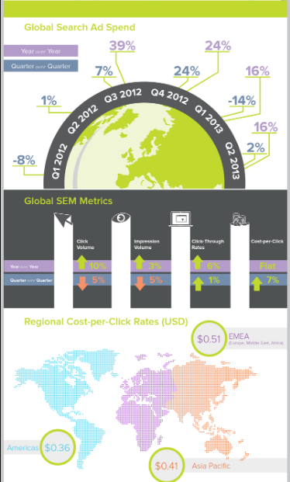

**Metaverse Global Revenues ($ Billion)**

*(Present this exactly as the sample image above (Half Globe)*

|  |  |  |  |  |  |  |
| --- | --- | --- | --- | --- | --- | --- |
| **Region** | **2022** | **2023** | **2024** | **2025** | **2026** | **2027** |
| GLOBAL | 62.40 | 89.90 | 135.10 | 192.00 | 260.60 | 344.70 |

**Consumer Applications Lead Market Growth**

*(Present this exactly as the sample image above (bar with icons and upward arrow)*

|  |  |
| --- | --- |
| **Application** | **Growth Rate** |
| Consumer | 43.8% |
| Industrial Manufacturing | 34.5% |
| Commercial | 38.9% |
| Healthcare | 41.5% |

Consumer



Industrial Manufacturing



Commercial



Healthcare



**Where the Opportunities Lie? ($ Billion)**

*(Present this exactly as the sample image (World Map)*

|  |  |
| --- | --- |
| **Region** | **Market Size** |
| North Americas | 28.2 |
| Europe | 15.2 |
| Asia-Pacific | 15.4 |

**Must-Know Industry Facts & Statistics**

*(Present the stats in the below image format)*

**$3.5** trillion to global GDP by 2031 will be contributed by the metaverse enabled virtual economy

**400** million monthly active users currently makeup the metaverse

**235** million monthly users make Roblox the biggest virtual world in the metaverse

**62%** of employees want to use the metaverse for world related tasks and opportunities

**18%** of metaverse investments comes from the IT sector, followed by education and finance

**38%** of metaverse technology market is made up by VR/AR technologies

**25%** of people will spend one hour or more each day in the Metaverse by 2027

**40%** of metaverse users are males

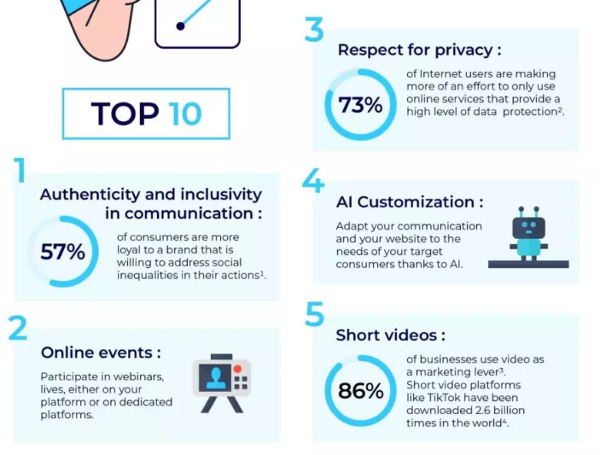

**Top Trends to Lookout for in 2023**

*(Present the stats in the below image format along with the icons copied for each trend)*

5G to fastrack metaverse Initiatives



Bold brands & their marketers to crack the metaverse mystery & mark their entry into the virtual world



Manufacturing in the metaverse hits prime time



Future of work will shift from WFH to WFM



Metaverse gaming becomes mainstream



Metaverse will become more interoperable & scalable



AR/VR technologies to create a more engaging & connected metaverse



Advanced avatar technology will make headway



